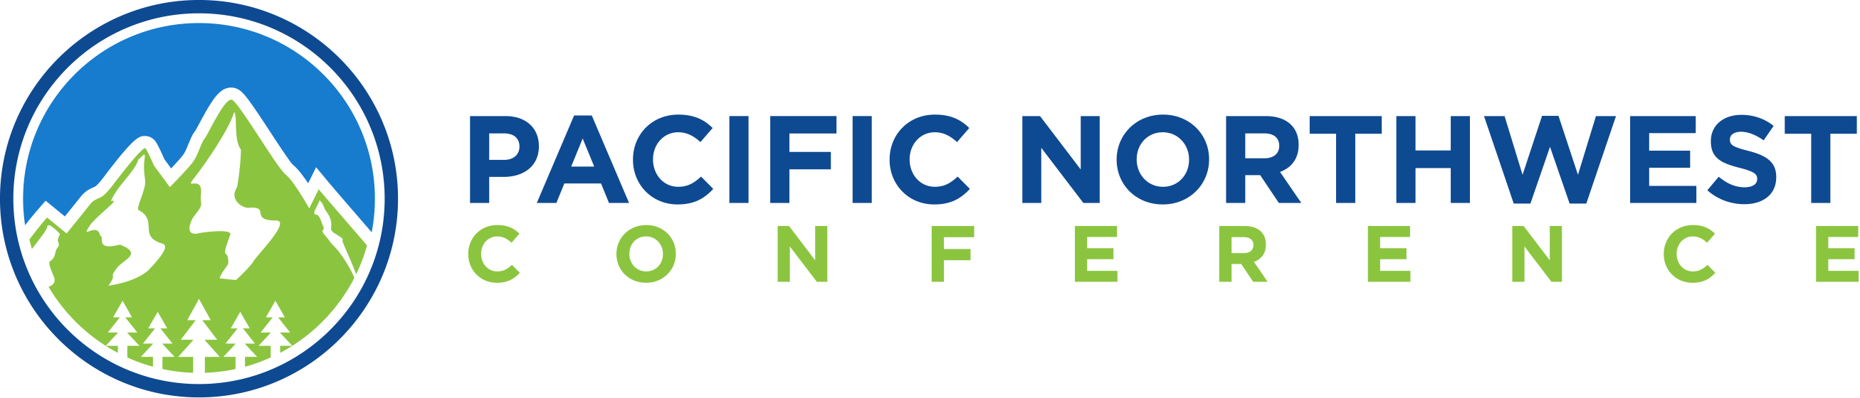

January 2026
Dear Church Planter,
The Pacific Northwest Conference Annual Meeting Celebration 2026 will be held April 23–25, 2026, at Columbia Grove Covenant Church in East Wenatchee, Washington. The celebration will begin on Friday afternoon with workshops, followed by a celebration dinner and a worship service. The business meeting will take place on Saturday morning, April 25, 2026, as a hybrid event, both in person and online. Ministerium events will be held on Thursday afternoon prior to the conference events. Please check here for the full schedule and details.
To guide your selection of advisors, please note the provisions outlined in the conference By-Laws regarding representation of church plant:

Article VII. Section 7.2 of the By-Laws reads as follows:

- A church plant within the Conference that is not yet a member congregation may send two advisors to the Annual Meeting.

After selecting advisors:

- Please complete the registration for the PacNWC Annual Meeting Celebration and arrange travel and lodging. Event information and registration is available at PacNWC.org.
- Please complete the form by March 31, 2026, to authorize your advisors. Make sure it is signed by the pastor or church chair, and list the names of all advisors representing your congregation.

Sincerely,
Laurie Roberts
Laurie Roberts
Secretary, PacNWC

