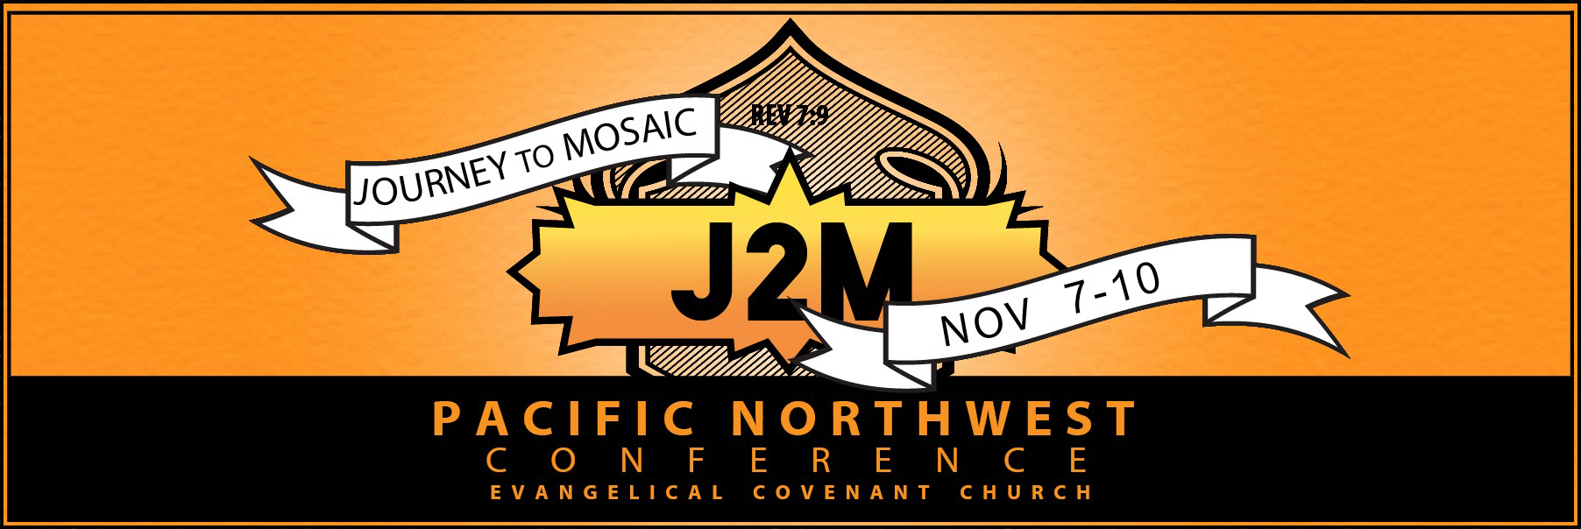

Thursday, November 7

2:00 pm Check-in and Introduction @ Nisei Veterans Committee Hall, Seattle
(1212 South King St., Seattle, WA 98144)

3:00 pm Presentation: Camp Survivors on Internment of Japanese-Americans in WWII
Video:

4:00 pm Tour NVC Hall museum

5:30 pm Dinner & Orientation at Japanese Cultural & Community Center
(1414 S. Weller St., Seattle, WA 98144)

8:30 pm Travel to host homes
Overnight in Seattle area

Friday, November 8

Breakfast on your own

7:45 am Gather at Kent Covenant Church to load the bus.
(12010 SE 240th St., Kent, WA 98031)

8:15 am Travel from Kent Covenant to Tacoma, WA (1/2 hr to 45 min)

9:00 am Site Visit: Chinese Reconciliation Park, Tacoma, WA (1741 N. Schuster Parkway)
Speaker: Chinese Reconciliation Park Foundation (Larry Hosley)

Site Visit: Northwest Detention Center, Tacoma, WA (1623 E. “J” St.)

10:30 am Travel up north (stopping by Everett for lunch and to Hibulb Cultural Center)

11:30 am Lunch on your own @ Fred Meyer (8530 Evergreen Way, Everett)

12:30 pm Travel to Hibulb Cultural Center (6410 23rd Ave NE, Tulalip, WA)

1:00 pm Site Visit: Hibulb Cultural Center, Tulalip, WA

6:00 pm Dinner @ Renew Covenant Church (2721 164th St SW, Lynnwood, WA)

7:00 pm Debrief

9:30 pm Overnight @ Hilton Garden Inn (1801 E Valley Rd, Renton, WA)

Saturday, November 9

Breakfast at the hotel (included)

8:30 am Bus departs from the hotel to ECBF (about 20 min).
Please be on the bus by 8:20 a.m.

9:00 am Presentation: Incarceration (Dominique Gilliard)
Emerald City Bible Fellowship
(7728 Rainier Ave S., Seattle, WA 98118)

African American Experience (Caenisha Warren)
1st Stop @ Safeway on Othello (3900 S Othello St., Seattle)
2nd Stop @ Mt. Zion Baptist Church (1634 19th Ave. S, Seattle)
3rd Stop/lunch stop @ Church of God Evangelistic Center (2715 S Jackson St, Seattle)
1:30 pm Travel to: Faith Covenant Church (1915 Washington St, Sumner, WA 98390)

2:00 pm Iglesia Esperanza Viva
Video:
Testimony

5:00 pm Dinner

7:00 pm Debrief

9:00 pm Travel to: Hilton Garden Inn (1801 E Valley Rd, Renton, WA)

Sunday, November 10

Breakfast at the hotel (included)

9:20 am Travel from Hilton Garden Inn to Radiant Covenant Church (20 minutes)
Please be on the bus and ready to roll at 9:30 a.m.

10:00 am Worship at Radiant Covenant Church
(Sartori Elementary School, 332 Park Ave N., Renton, WA 98057)

Noon Lunch & Closing group time/Communion

2:00 pm Travel to Kent Covenant Church (12010 SE 240th St., Kent, WA 98031)

