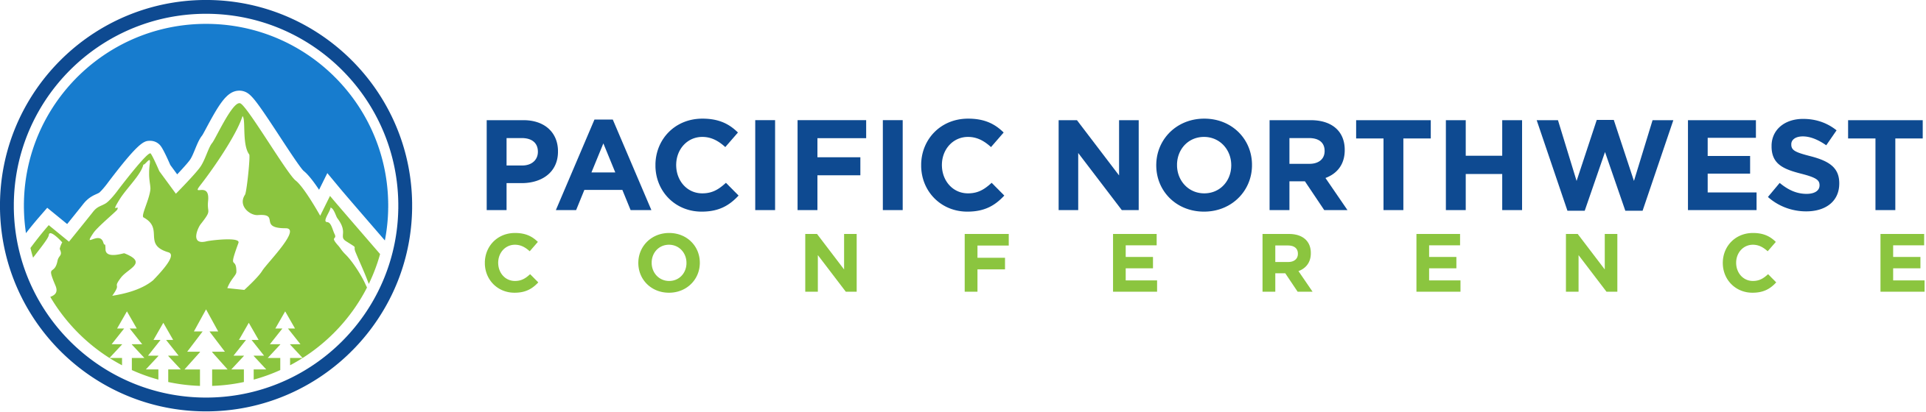

134th Annual Celebration

April 18 – 20, 2024

First Covenant Church, Portland, OR (for Ministerium)
Milwaukie Covenant Church, Milwaukie, OR (for Delegates & General Conferees)

Ministerium
(open to all clergy and staff)

Thursday, April 18, 2024
@ First Covenant Church (4433 E Burnside St., Portland, OR)

2:00 – 2:45 PM Welcome & Worship
2:45 – 5:30 PM Ministerium Continuing Ed
6:00 – 8:00 PM Celebration Dinner

Friday, April 19, 2024
@ First Covenant Church (4433 E Burnside St., Portland, OR)

8:30 AM Coffee & Fellowship
9:00 AM Ministerium Annual Business Meeting
12:00 PM Ministerium Lunch & Fellowship

PacNWC Annual Celebration
(open to delegates and general conferees)

Friday, April 19, 2024
@ Milwaukie Covenant Church (12201 SE Linwood Ave., Milwaukie, OR)

1:00 PM PacNWC Delegates & General Conferees Registration
2:00 – 3:15 PM Q&A with ECC President, Tammy Swanson-Draheim
3:30 – 4:45 PM PacNWC Workshop 1 & 2
5:30 PM Celebration Dinner
7:00 – 9:00 PM Prayer & Worship

Saturday, April 20, 2024
@ Milwaukie Covenant Church (12201 SE Linwood Ave., Milwaukie, OR)

7:00 – 8:30 AM Covenant Men’s Breakfast
8:00 AM PacNWC Delegates & General Conferees Registration
9:00 AM PacNWC Annual Business Meeting
12:00 PM Boxed Lunch

Workshops

Time | Title | Title
2:00 – 3:15 PM | Q & A with ECC President, Tammy Swanson-Draheim
3:15 – 3:30 PM | Break | Break
3:30 – 4:45 PM | Nancy Sugikawa | Erik Cave

List of Hotels in Milwaukie area

*Coming later.

Registration Form

Name:
Church Name:
Delegate or General Conferee:
E-mail:
Phone:

 | In person | Online
Delegate (Sat)
General Conferee (Fri & Sat)
Celebration Dinner (Fri)
Praise & Worship (Fri)
Q&A with ECC President (Fri)
Workshop #1 (Fri)
Workshop #2 (Fri)
Boxed Lunch (Sat)
Registration Fee | $30.00 per person | No Charge
Ministerium Continuing Ed & Dinner (Thurs)
Ministerium Business Meeting & Lunch (Fri)
Registration Fee | $25.00 per person | No Charge
Covenant Men’s Breakfast | $12.00 per person
Total Fee

Registration options:
By mail: Pacific Northwest Conference
9311 SE 36th Street Suite 108
Mercer Island, WA 98040
Online: www.pacnwc.org/annualmeeting

Registration deadline: April 5, 2024

